- Write a program to find the largest number in an array.
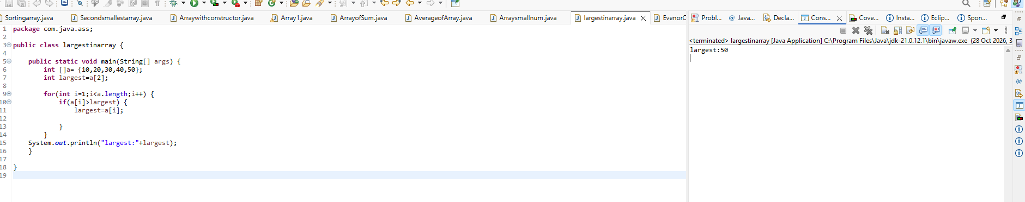
2.Write a program to find the smallest number in an array.
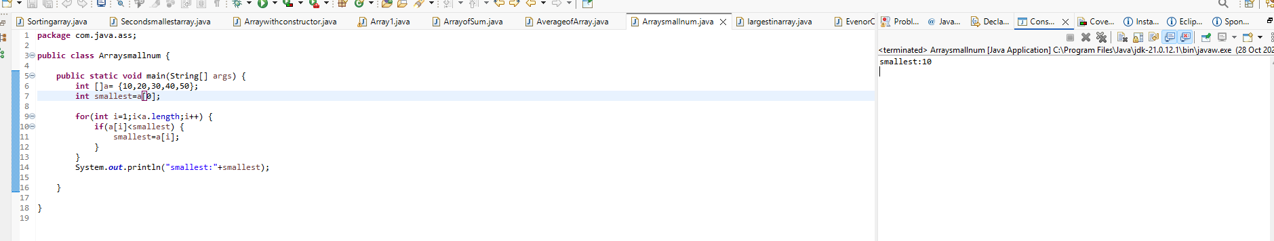

3Write a program to count how many even and odd numbers are present in an array.
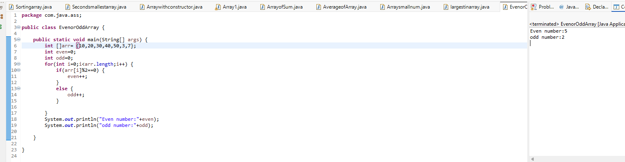

4.Write a program to count positive numbers, negative numbers and zeros in an array.
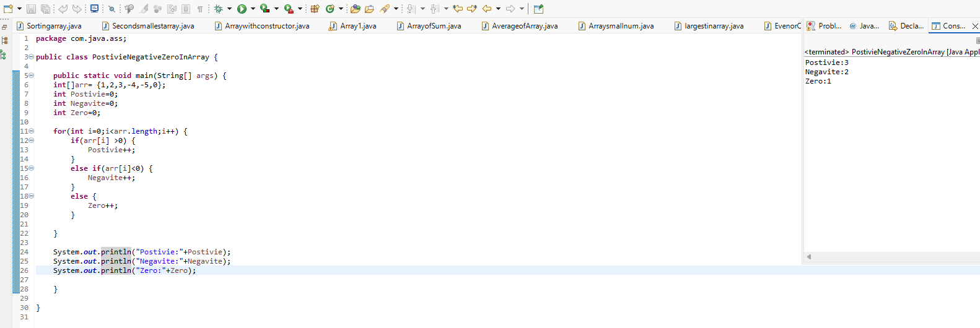
5.Write a program to calculate the average of all elements in an array
